- Communication Test Between Laptop and Phone Using Ping Command

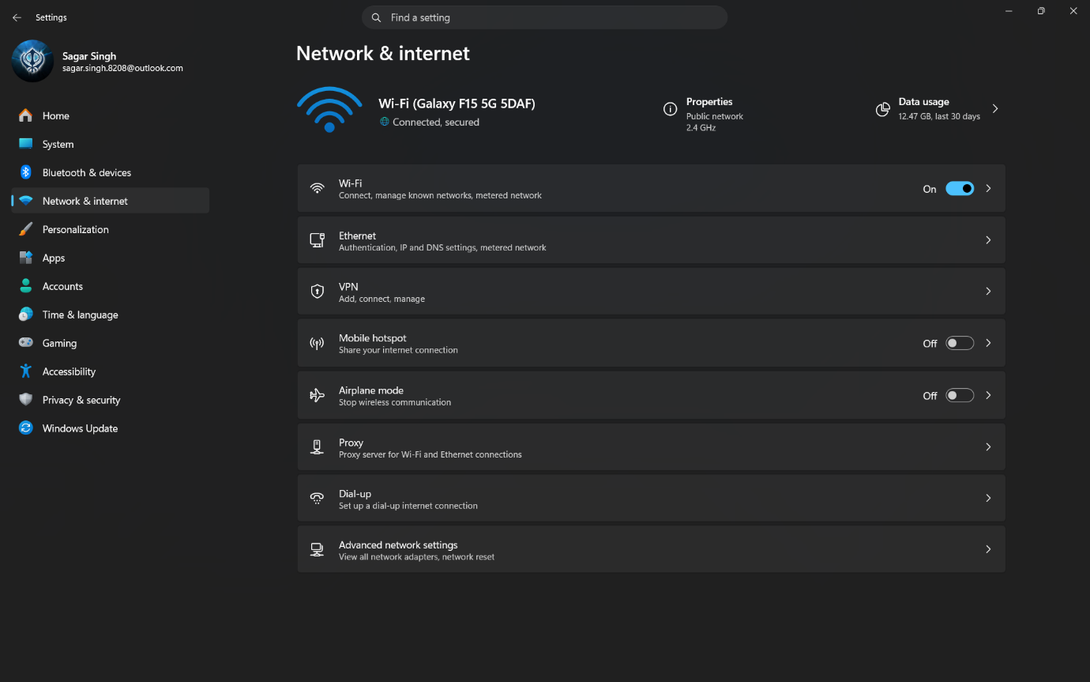

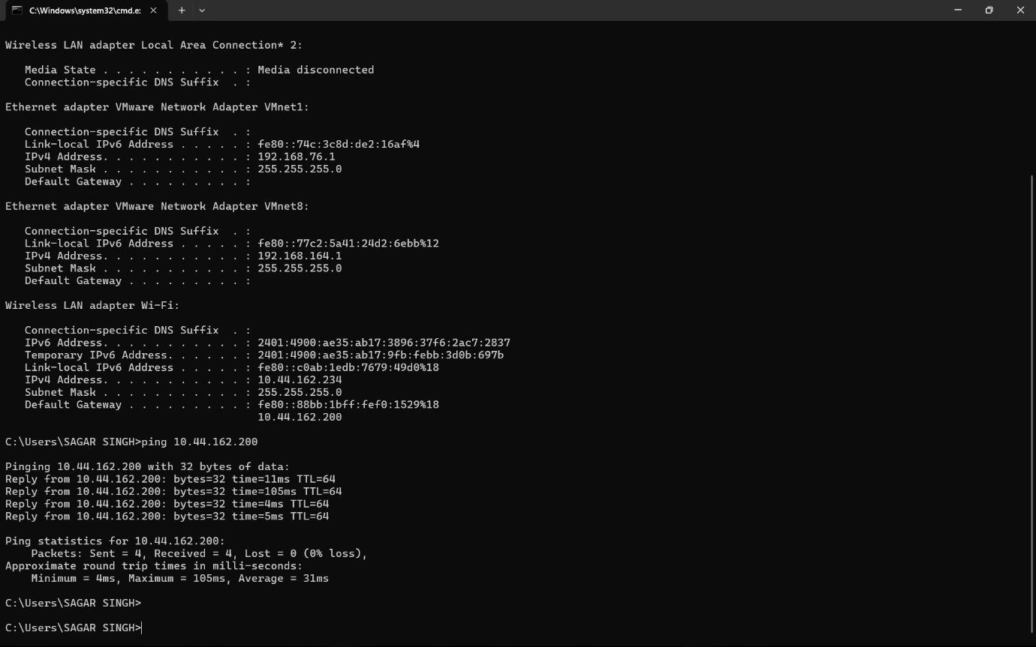
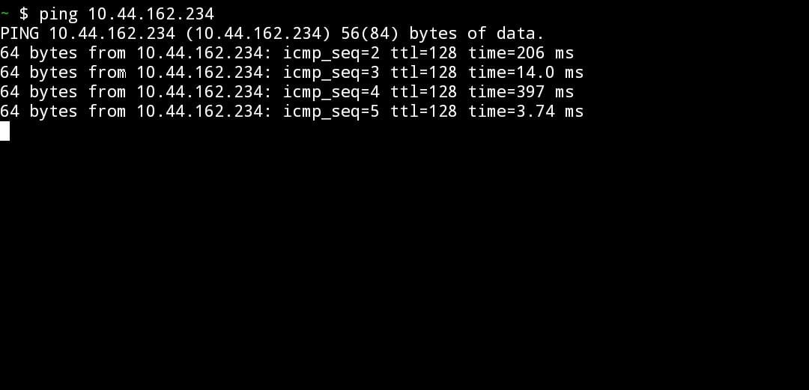
- Procedure:
- Turned on the phone's hotspot.
- Connected the laptop to the phone's hotspot.
- Opened Command Prompt on the laptop and used the ipconfig command to find the laptop's IPv4 address.
- Opened Termux on the phone.
- Used the ping command with the laptop's IP address.
- Received successful replies, confirming that both devices could communicate.

- Conclusion:
The laptop and phone were connected to the same network using the phone's hotspot. The ping command was successful, which confirmed that both devices could communicate with each other.

- Traceroute to www.youtube.com⁠

1. Objective
To find the number of hops required to reach www.youtube.com⁠ using the tracert command.
2. Command Used
tracert www.youtube.com
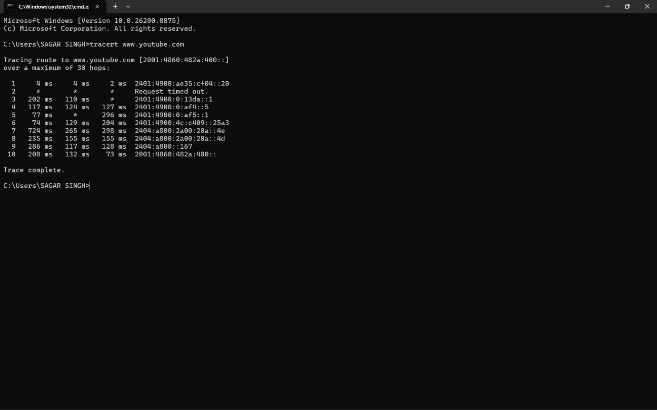
3. Observation
Total number of hops: 10
The traceroute reached www.youtube.com⁠ successfully.
One hop showed Request timed out, but the trace completed successfully.
- Conclusion:
The tracert command showed that the data packets reached www.youtube.com⁠ in 10 hops. Each hop represents a router or network device through which the packets passed before reaching the destination.

- Ping Test After Disconnecting a Wi-Fi Device

- Objective
To observe the error message when a device is disconnected from the Wi-Fi network.
Command Used in Termux
- ping 10.44.162.234
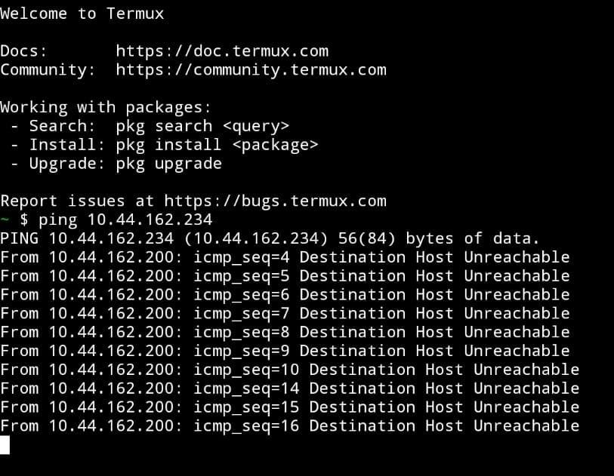
- Observation
- The laptop was disconnected from the Wi-Fi network.
- When the ping command was executed from the phone, the message "Destination Host Unreachable" was displayed.
- This indicates that the laptop could not be reached over the network.
- Conclusion
After disconnecting the laptop from the Wi-Fi network, the phone was unable to communicate with it. Therefore, the ping request failed and the error "Destination Host Unreachable" was displayed.

- IP Addresses of Devices Connected to My Network Using ARP
1. Objective
To view the IP addresses of devices connected to the local network using the arp -a command.
2. Command Used
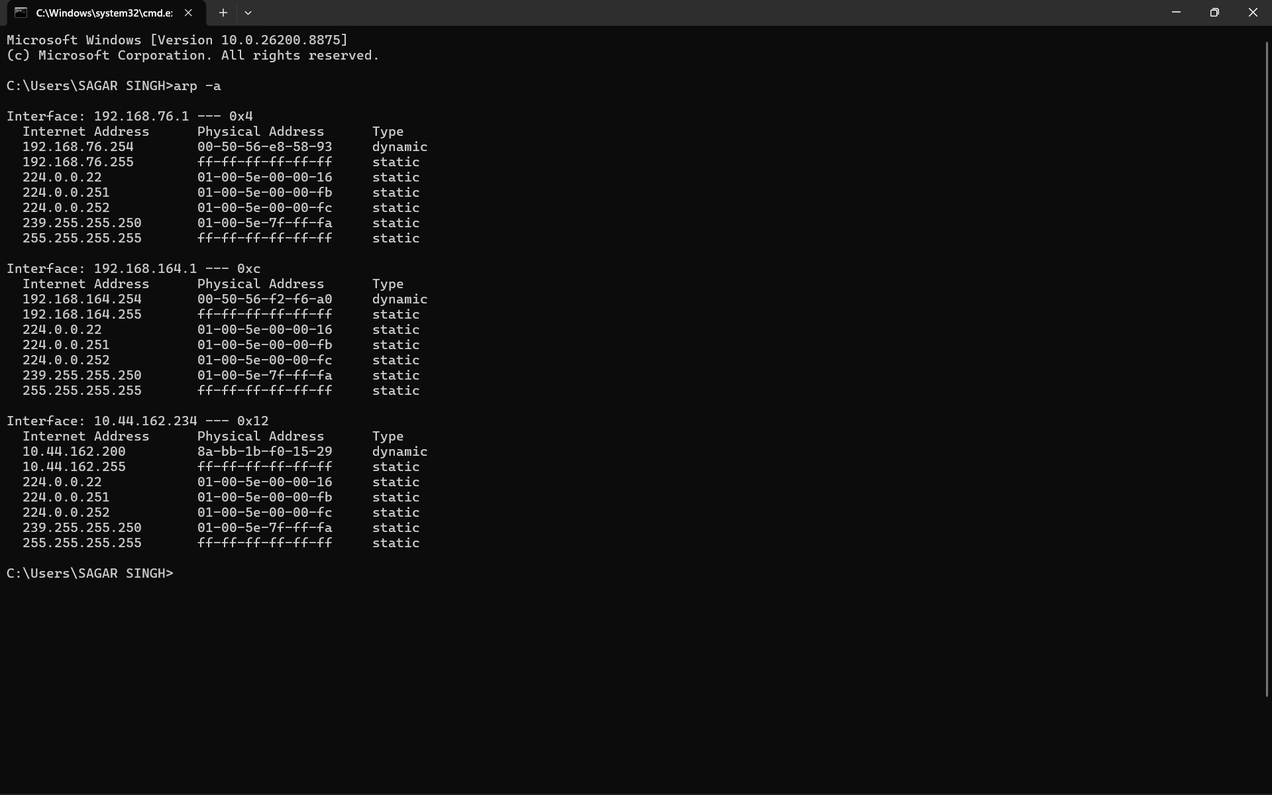
arp -a

3. Table
IP Address | Device / Person
- 10.44.162.234 | My Laptop
- 10.44.162.200 | My Phone (Hotspot)

4.Observation
- The arp -a command displayed the devices available on the local network.
- My laptop had the IP address 10.44.162.234.
- My phone (hotspot) had the IP address 10.44.162.200.
5. Conclusion
The arp -a command was used to view the IP addresses of devices on the local network. It helped identify the laptop and the phone hotspot connected to the network.

- Report: Network Setup, Ping and Traceroute Testing

- Introduction:
In this practical, I connected my laptop and mobile phone to the same home Wi-Fi network to test network connectivity. I used the ping and traceroute (tracert) commands to check communication between devices and to understand how data travels across a network.
- Step 1: Network Setup
- Connected my laptop to the home Wi-Fi network.
- Connected my Android phone to the same Wi-Fi network.
- Found the IP address of my laptop using the ipconfig command in Command Prompt.
- Installed Termux on my Android phone to run networking commands.

- Step 2: Testing Connectivity Using Ping
- Opened Termux on my phone.
- Ran the following command:
ping 10.44.162.234
- The phone received replies from the laptop, confirming that both devices were connected and could communicate with each other on the same network.

- Observation:
The ping command showed successful replies with response times in milliseconds, which confirmed that the network connection was working properly.

- Step 3: Testing Connectivity Using Traceroute
- Opened Command Prompt on the laptop.
- Ran the following command:
tracert youtube.com
- The command displayed the path (hops) that the data packets followed to reach the destination server.

- Observation:
The traceroute showed multiple hops through my Internet Service Provider before reaching the destination. Some hops displayed Request Timed Out, which is normal because some routers do not respond to traceroute requests.

- Issues Observed:
- Initially, the ping test did not work because the required settings were not configured correctly.
- After enabling the necessary settings and verifying the IP address, the ping command worked successfully.
- During the traceroute test, a few hops showed Request Timed Out or Destination Host Unreachable. These messages can occur due to firewall settings, router security, or because some network devices are configured not to reply to traceroute requests.

- Conclusion:
This practical helped me understand how devices communicate over a network and how to test connectivity using the ping and tracert commands. The successful ping replies confirmed that my devices were connected correctly, while the traceroute command demonstrated the route taken by data packets across the Internet. Overall, the network setup and connectivity tests were completed successfully.

